ASSIGNMENT NO.8: Views and Data Abstraction

Student Name | Anushka Pachpute | Roll Number | 20971
Batch | SY. BSc Data Science | Topic | WB(Assignment-8)

Q1) Create a MySQL database named CollegeDB and create two tables: Course and Student.

Course Table
Column Name | Data Type | Constraint
CourseID | INT | PRIMARY KEY
CourseName | VARCHAR(50) | NOT NULL
Fees | DECIMAL(10,2) | NOT NULL

Student Table
Column Name | Data Type | Constraint
StudentID | INT | PRIMARY KEY
StudentName | VARCHAR(50) | NOT NULL
CourseID | INT | FOREIGN KEY
City | VARCHAR(30)
Marks | INT
Email | VARCHAR(60)
Insert at least 4 course records and 10 student records.

QUERY:

CREATE DATABASE CollegeDB;
USE CollegeDB;

CREATE TABLE Course (
CourseID INT PRIMARY KEY,
CourseName VARCHAR(50) NOT NULL,
Fees DECIMAL(10,2) NOT NULL
);

INSERT VLAUES:
INSERT INTO course (CourseID, CourseName, Duration, Fees, Tier) VALUES
(101, 'B.Sc IT', '3 Years', 35000.00, NULL),
(102, 'BCA', '3 Years', 40000.00, NULL),
(103, 'BBA', '3 Years', 50000.00, NULL),
(104, 'Bsc DATA SCIENCE', '3 Years', 60000.00, NULL),
(105, 'MCA', '3 Years', 45000.00, NULL),
(106, 'B.Com', '3 Years', 60000.00, NULL),
(107, 'CSE', '4 Years', 80000.00, NULL),
(108, 'MSE', '2 Years', 50000.00, NULL);

CREATE TABLE Student (
StudentID INT PRIMARY KEY,
StudentName VARCHAR(50),
Age INT,
Course VARCHAR(30),
City VARCHAR(30),
Marks INT,
Email VARCHAR(60)
);

INSERT INTO student
(StudentID, StudentName, Email, Phone, Gender, DateOfBirth, CourseID, AdmissionDate, Age, City, Marks)
VALUES
(1, 'Amit Sharma', 'amit@gmail.com', '9876543210', 'M', '2005-04-12', 101, '2026-07-07', 20, 'Mumbai', 85),
(2, 'Ram Rohan', 'ram@gmail.com', '9845563210', 'M', '2007-04-16', 102, '2025-06-17', 21, 'Mumbai', 78),
(3, 'Anisa Patil', 'anisa@gmail.com', '9848809543', 'F', '2006-05-12', 103, '2024-04-03', 22, 'Pune', 92),
(4, 'Rita Nayak', 'rita@gmail.com', '9267563710', 'F', '2004-08-15', 104, '2025-03-23', 20, 'Mumbai', 74),
(5, 'Rohan Mehta', 'abc@gmail.com', '9875643993', 'M', '2004-11-25', 105, '2026-07-08', 23, 'Delhi', 88),
(6, 'Arjun Nair', 'arjun@gmail.com', '9876540321', 'M', '2009-08-24', 107, '2026-08-05', 24, 'Pune', 95),
(7, 'Aditya Ballal', 'aditya@gmail.com', '9876004532', 'M', '2009-08-25', 108, '2026-05-18', 21, 'Mumbai', 76),
(8, 'Vikas Sharma', 'vikas@gmail.com', '9876541111', 'M', '2005-01-10', 102, '2026-07-26', 20, 'Thane', 89),
(9, 'Rohit Desai', 'rohit@gmail.com', '9834567091', 'M', '2004-11-20', 103, '2026-08-09', 21, 'Mumbai', 83);

OUTPUT:

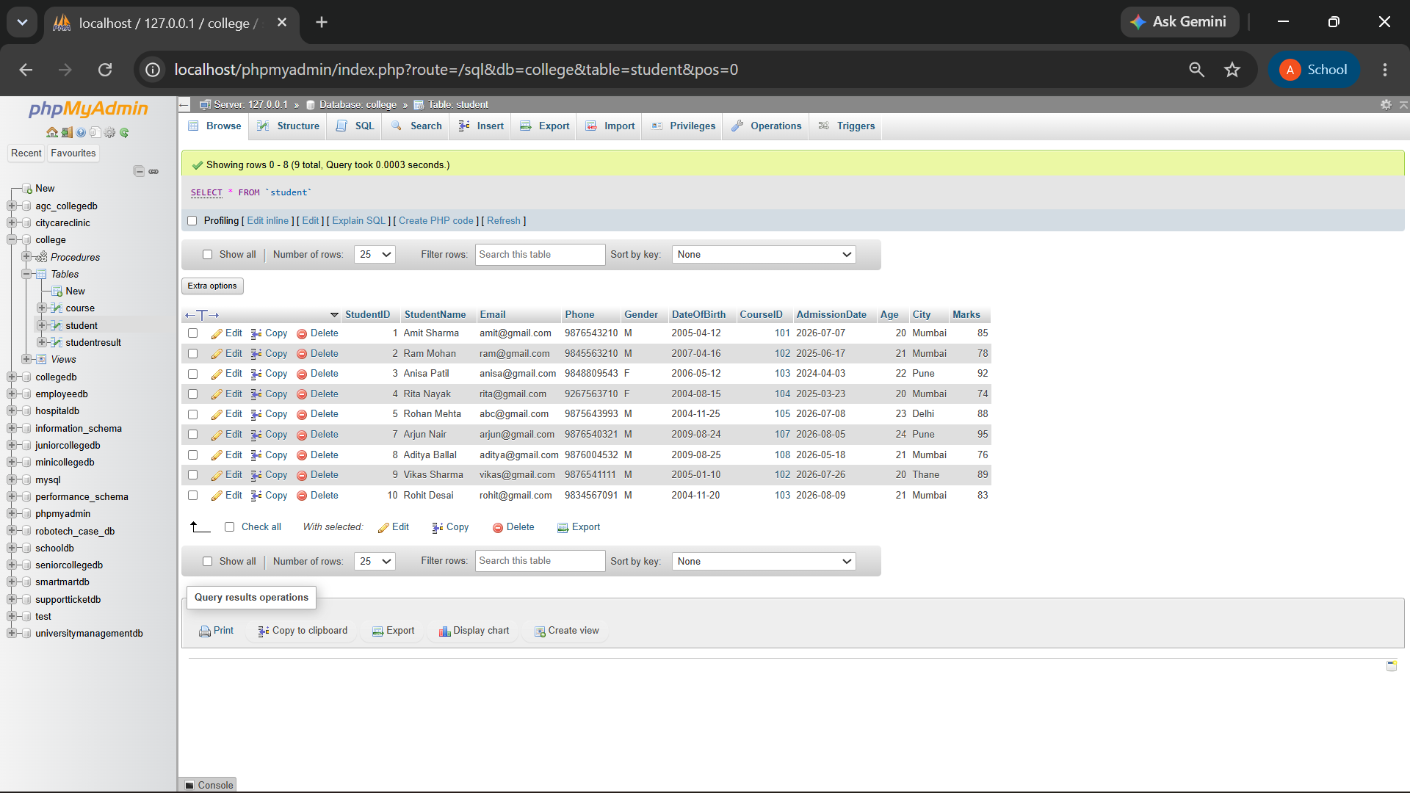
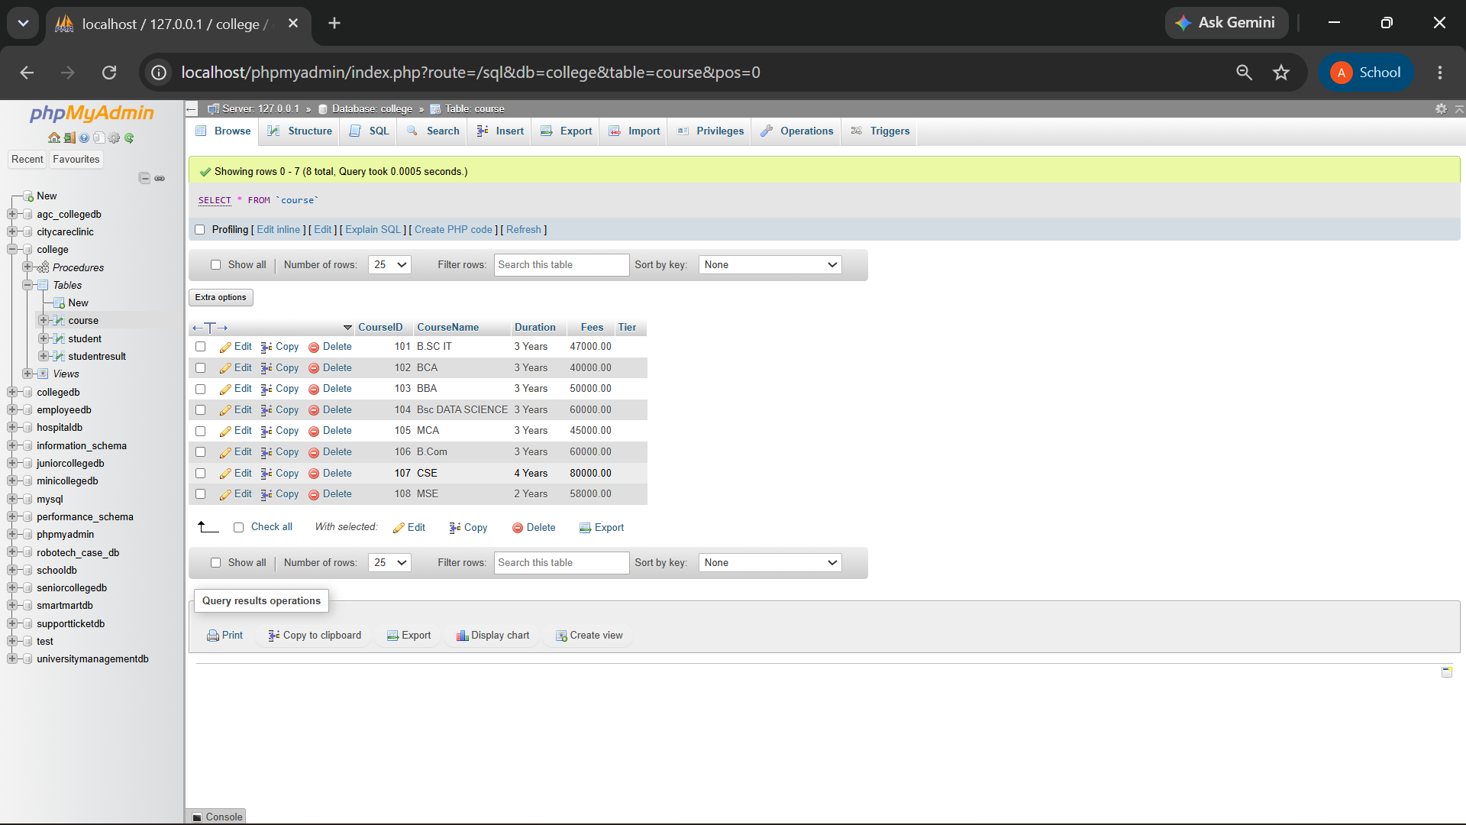

Q2) Create a view named StudentBasicView to display only selected student details.
The view should contain:
Column
StudentID
StudentName
City
Marks

QUERY:

CREATE VIEW StudentBasicView AS
SELECT StudentID, StudentName, City, Marks FROM Student;
SELECT * FROM StudentBasicView;

OUTPUT:

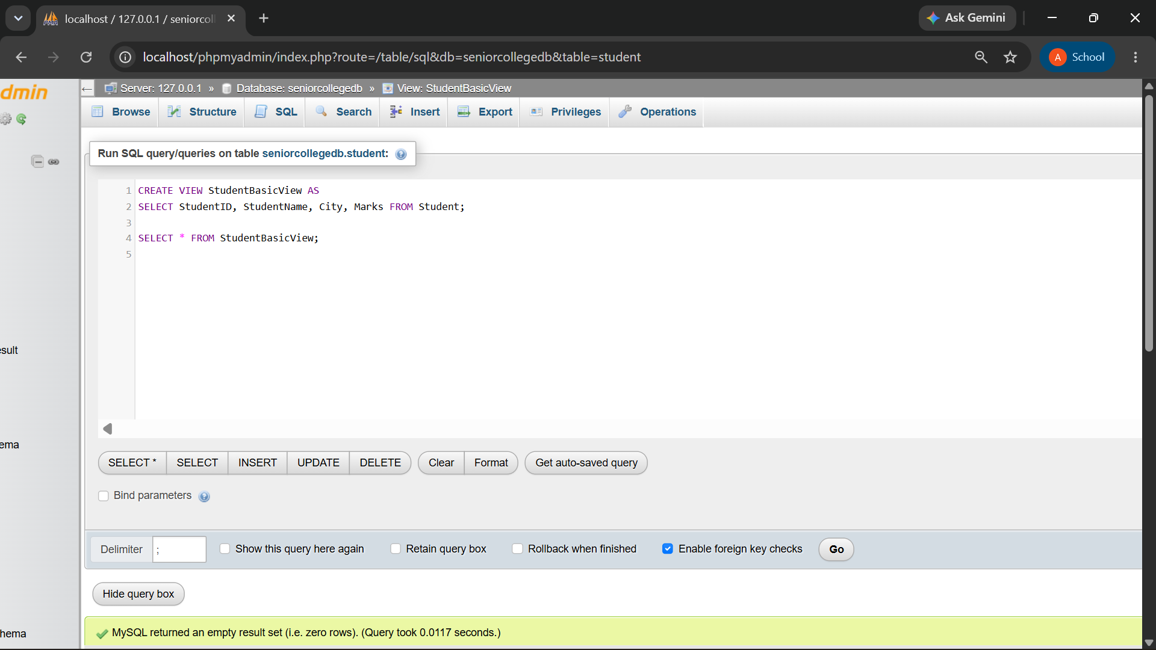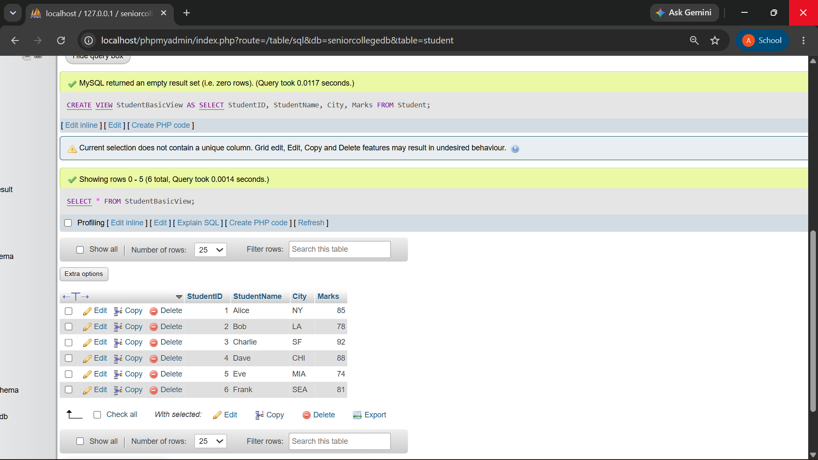

Q3) Create a view named StudentCourseView using Student and Course tables.
The view should display:
Column
StudentID
StudentName
City
Marks
CourseName
Fees

QUERY:
CREATE VIEW StudentCourseView AS SELECT
Student.StudentID, Student.StudentName, Student.City, Student.Marks, Course.CourseName, Course.Fees
FROM Student INNER JOIN Course
ON Student.CourseID = Course.CourseID;

SELECT * FROM StudentCourseView;

OUTPUT:

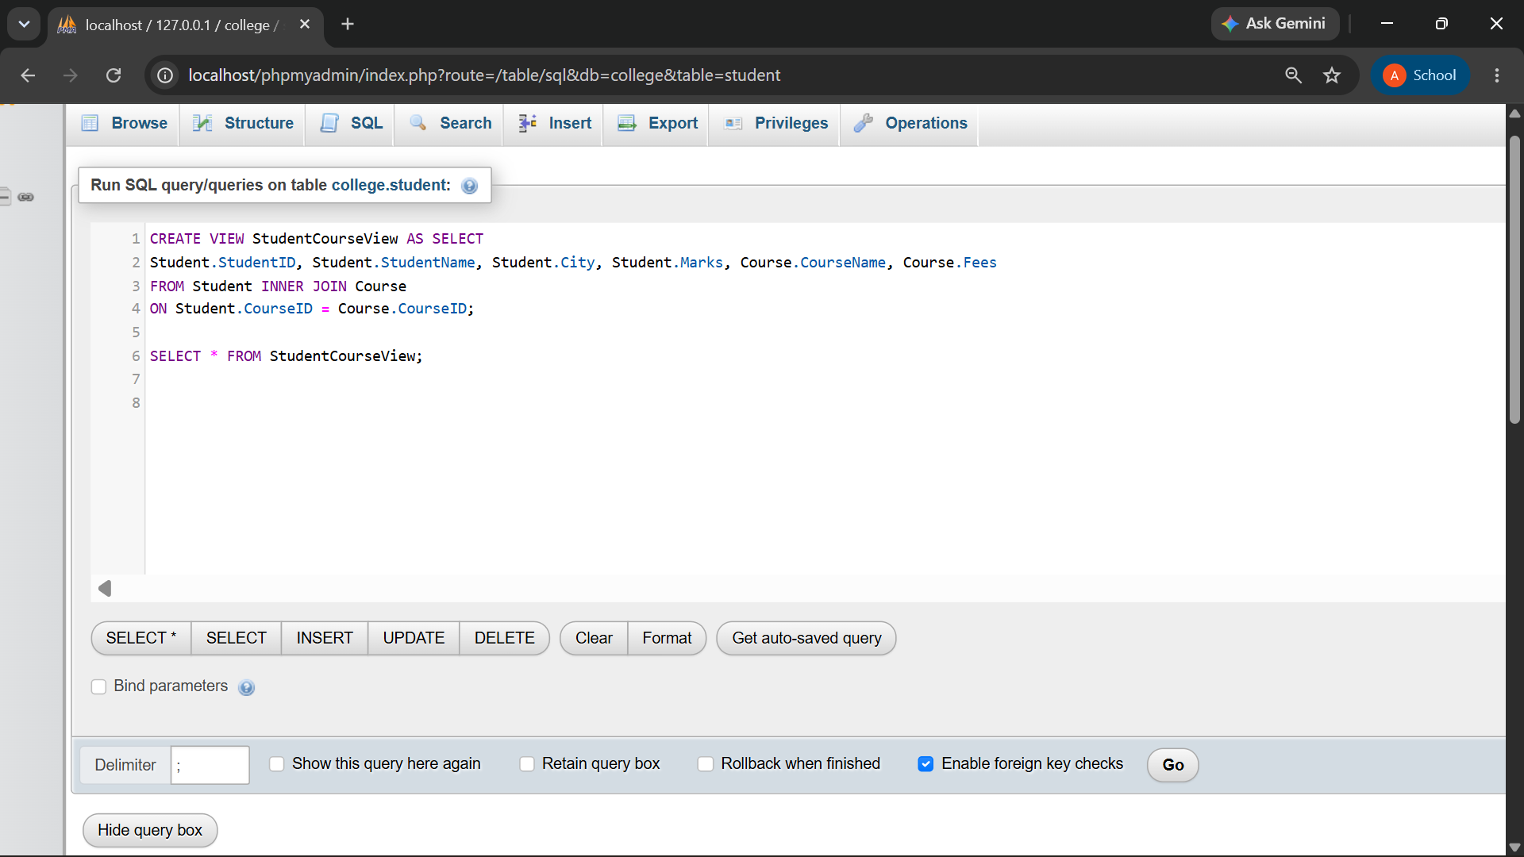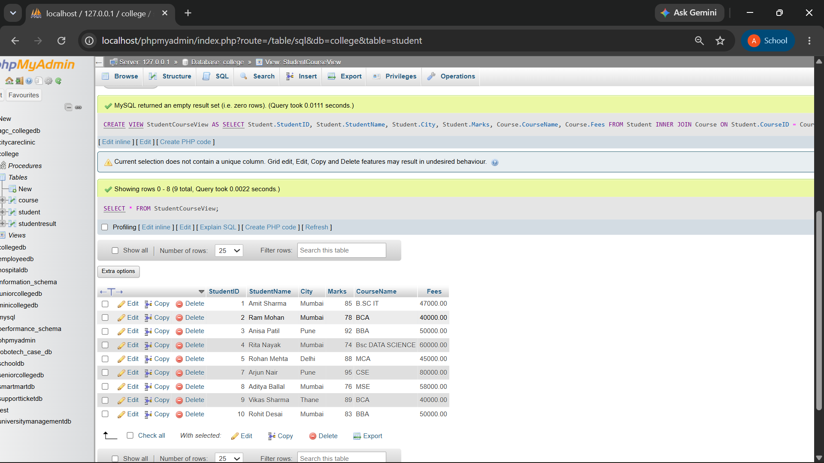

Q4) Write a MySQL query using StudentCourseView to display students from Mumbai.
The output should contain:
Column
StudentName
City
CourseName
Marks

QUERY:

SELECT StudentName, City, CourseName, Marks FROM StudentCourseView
WHERE City = 'Mumbai';

OUTPUT:

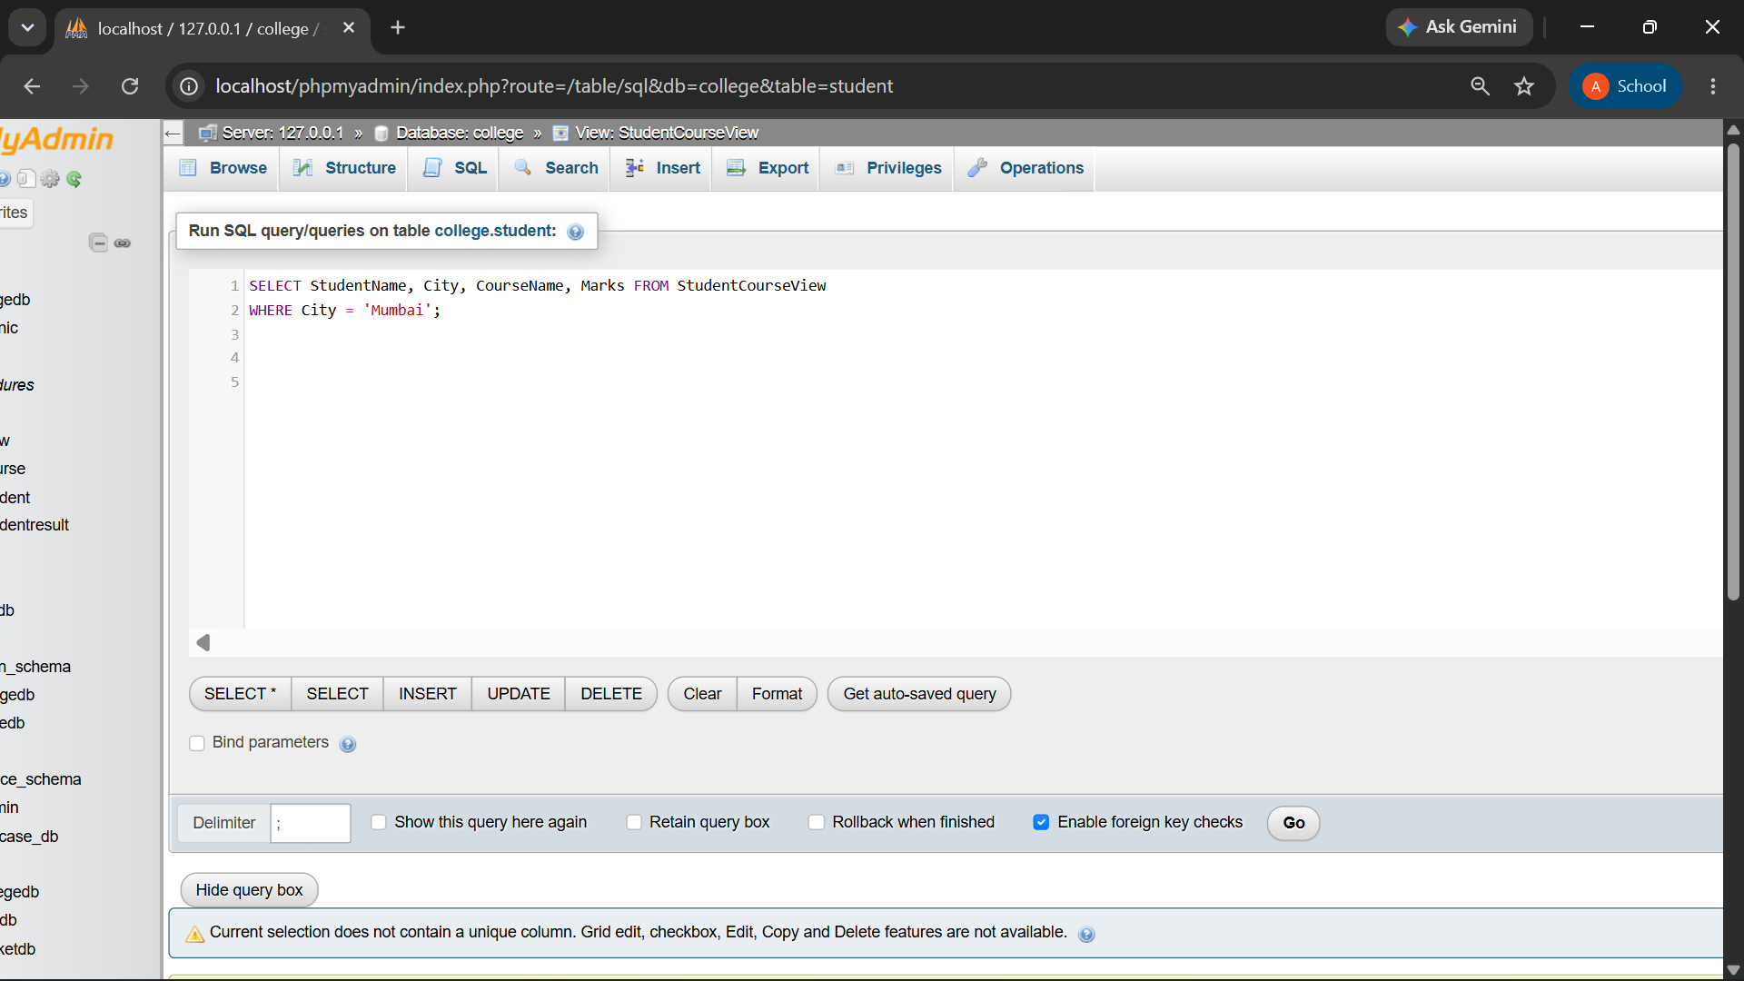

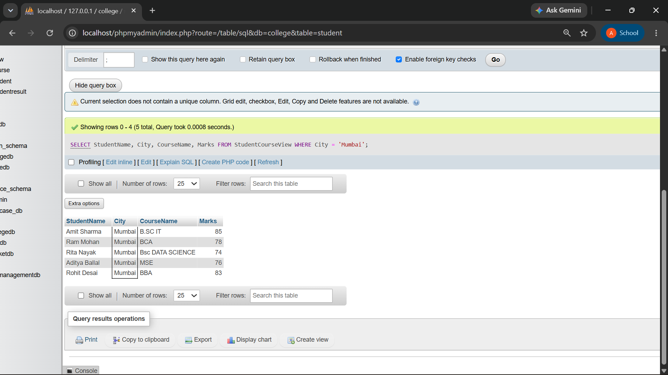

Q5) Write a MySQL query using StudentCourseView to display students sorted by marks in descending order.
The output should contain:
Column
StudentName
CourseName
Marks

QUERY:

SELECT StudentName, CourseName, Marks FROM StudentCourseView
ORDER BY Marks DESC;

OUTPUT:

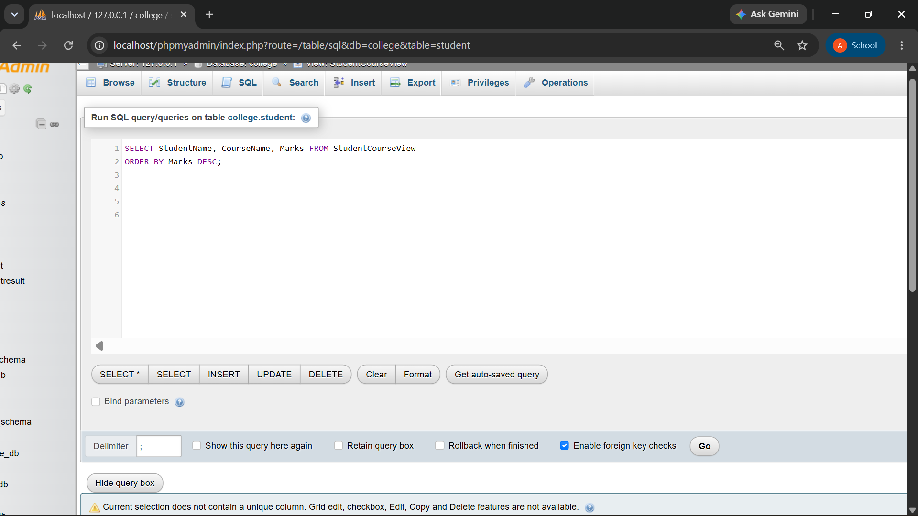
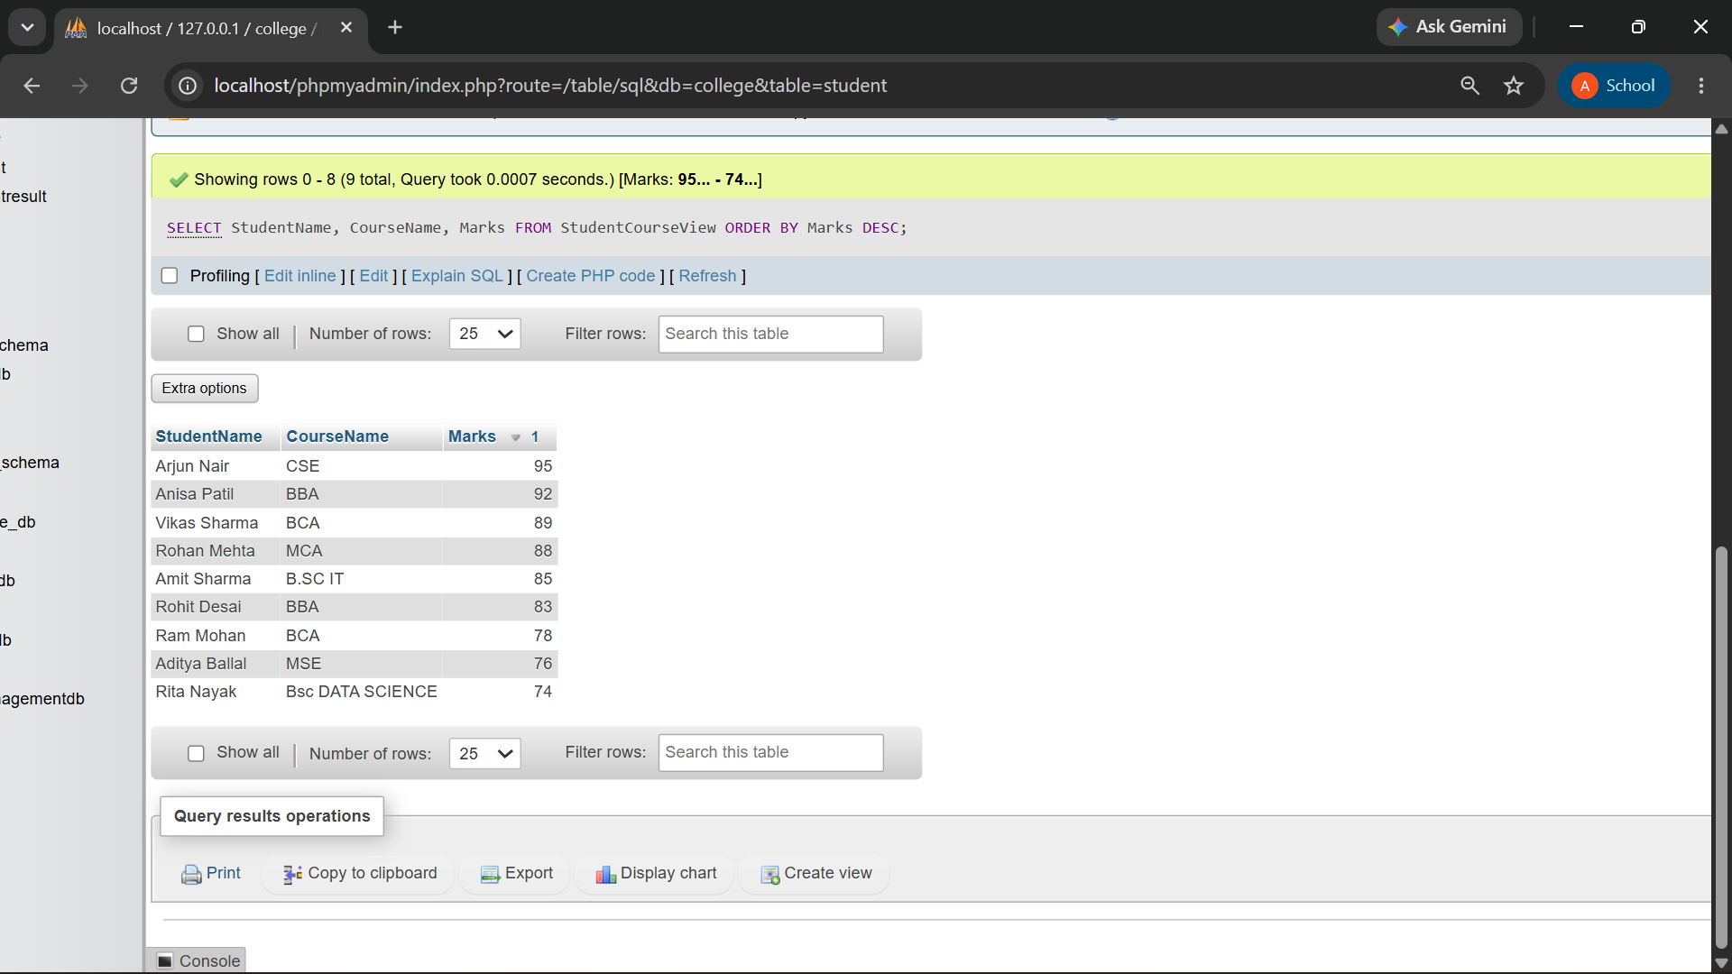

Q6) Create a report view named ManagementReportView.
The view should display course-wise summary:
Column
CourseName
TotalStudents
AverageMarks
LowestMarks
HighestMarks

Also write one line explaining why such a view is useful in reporting.

QUERY:
CREATE VIEW ManagementReportView AS SELECT
Course.CourseName, COUNT(Student.StudentID) AS TotalStudents, AVG(Student.Marks) AS AverageMarks, MIN(Student.Marks) AS LowestMarks, MAX(Student.Marks) AS HighestMarks
FROM Course
LEFT JOIN Student
ON Course.CourseID = Student.CourseID GROUP BY Course.CourseName;
SELECT * FROM ManagementReportView;

OUTPUT:

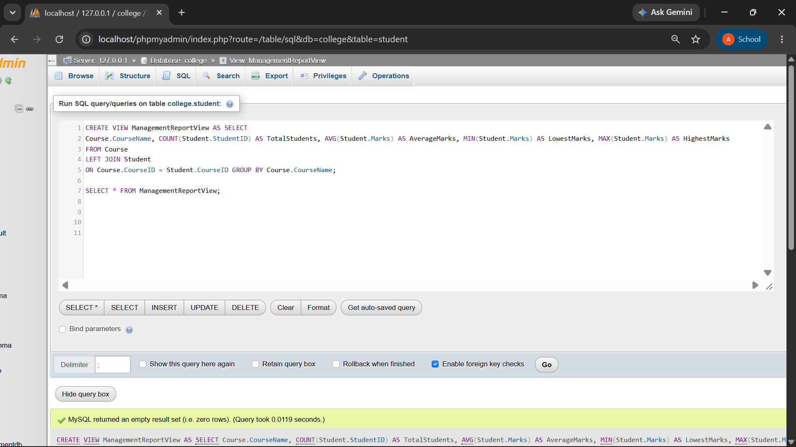
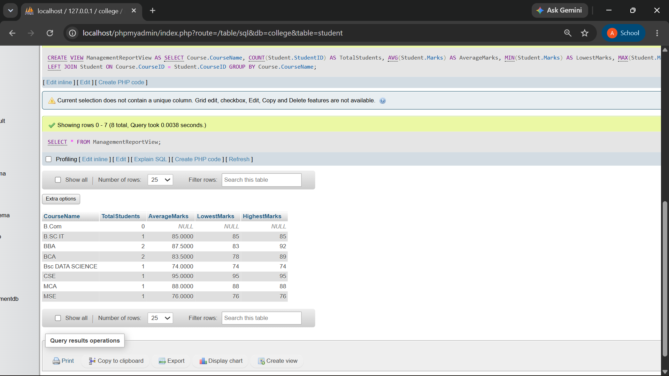
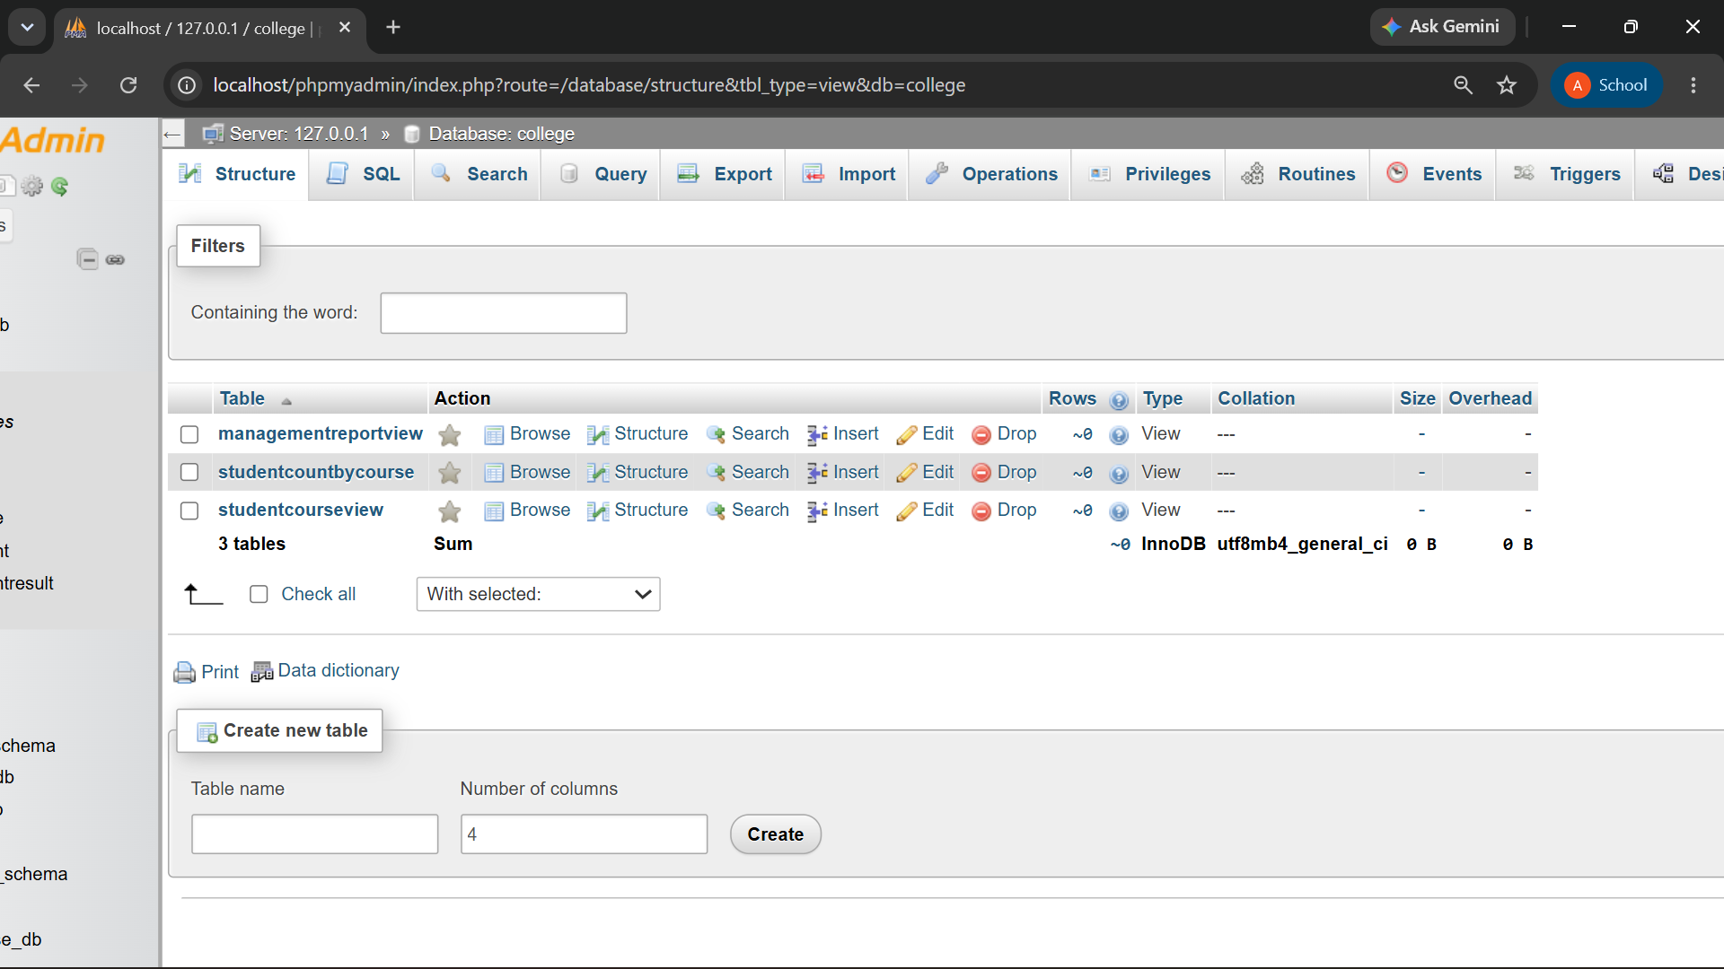

A report view stores complex reporting logic in one reusable object, making management reports easier to generate and maintain.
The ManagementReportView is useful for generating a clear course-wise performance report. It shows the total number of students along with their average, lowest, and highest marks. This helps management compare courses and understand student performance easily. It also saves time by providing the required information in a single view.

